“...but the world may be different because I was important in the life of a child.”

H.P.A.L. Scholarships, Awards and Benefit Fund Dinner Dance 2013

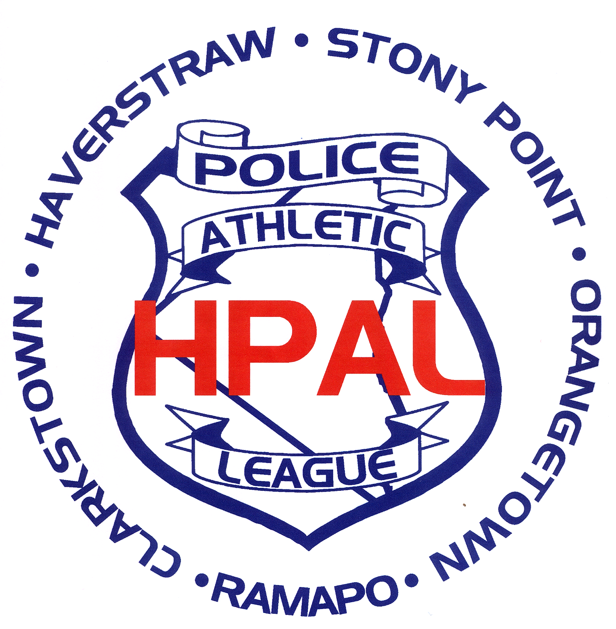

The Officers and Board Members
of H.P.A.L.
cordially invite you to join them
for an evening gala to honor those
who make a difference in the
lives of the children in our community

Honoring:

HOWARD PHILLIPS TIM PALMER
Town of Haverstraw Supervisor Volunteer Coach

KNIGHTS OF COLUMBUS

For their devoted service and commitment to the community.

Please join us on October 4, 2013
at 7:00 p.m. and will be held at
Town and Country, Rte. 9W, Congers, N.Y.

Tickets: $55.00

Ask any Volunteer / HPAL Board Member for the
HPAL 2013 Scholarship Dinner Dance Order Form
or download from our website: www.hpalinc.org
October 4, 2013 @ 7:00PM
Town and Country, Route 9W, Congers, NY

NAME________________________________________________

Number of Tickets: ___ x $55.00 =____________

Tickets will be held at door. NO TICKETS WILL BE MAILED. If you would like confirmation that your order was received, supply e-mail address:

EMail:______________________________________

MAIL FORM TO:
Dinner Committee Chair
PO BOX 238, GARNERVILLE, NY 10923
Need further information? Call us at 845-641-5461or send us an email: hpal@hpalinc.org

Do not write below this line

TABLE #________________ Presentation #____________

